3 The Home Page SASS

Contents

Create Home partial SCSS 1

Go to main.scss to import Home 1

Turn on SASS 2

Go to index.html to test the page 2

Styling the Home Text 3

Testing the Text on the home page 4

Turn on SASS 4

Go to index.html to test the page 5



# Create Home partial SCSS

Create a new partial and name it _home.scss

.home{

height:100%;

padding-top: 40vh;

overflow: hidden;

align-items: center;

text-align: center;

background: url('../img/home-image.jpg');

background-size:cover;

}

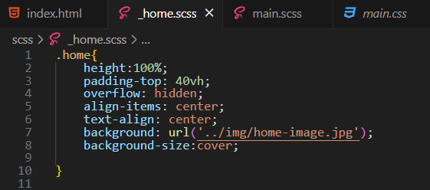

# Go to main.scss to import Home

@import"home";

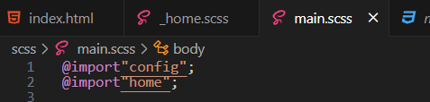

# Turn on SASS

At the bottom of the app

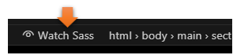

# Go to index.html to test the page



# Styling the Home Text

We are just going to be targeting the fonts inside of the .home rule. We will be using the &. The & sign is used in SCSS when we want to nest something, which is exactly what we are going to do.

.home{

height:100%;

padding-top: 40vh;

overflow: hidden;

align-items: center;

text-align: center;

background: url('../img/home-image.jpg');

background-size:cover;

&__name{

font-size: 3.5rem;

padding-bottom: 1rem;

border-bottom: 2px solid #fff;

&--last {

color: $secondary-color;

font-weight: 300;

}

}

}

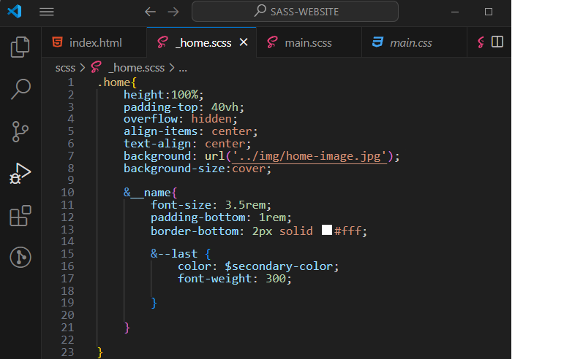

# Testing the Text on the home page

# Turn on SASS

At the bottom of the app



# Go to index.html to test the page

